
Raspberry Pi

194 Cambridge Science Park
Cambridge
CB4 0AB

Raspberry Pi Ltd
Supply Chain Code of Conduct Fourth Edition, 16 May, 2024

Definitions
“RPL” means Raspberry Pi Ltd
“Code” means this Supply Chain Code of Conduct.
“RBA Code of Conduct” means a set of standards in the electronics industry established by RBA (Responsible Business Alliance) http://www.responsiblebusiness.org/
“Supplier” means (1) a company that supplies any product to RPL, (2) a company that supplies any product to a sub-contract manufacturer nominated by RPTL for the manufacture of any RPL product (3) a company providing any other service for RPL either directly or via a third party.
“Operational Rules” means the Operational Rules for the RPL Supply Chain Code of Conduct defining rules about the internal procedures and processes for the Code, monitoring the Electronics Manufacturing Sites’ and Suppliers’ compliance with the Code, and actions to be taken in the event of the possibility of non-compliance with the Code.

It is RPL’s fundamental policy to comply with all applicable laws and regulations of the countries and regions in which it operates and to conduct its business activities in an honest and ethical manner. The RPL Code of Conduct requires its suppliers to uphold the policies of RPL concerning compliance with all applicable law, respect for human rights, environmental conservation and the safety of products and services.
RPL believes that the RBA Code of Conduct serves as an important framework for both sub contract manufacturers and Suppliers to conduct their business in a socially responsible manner and hereby adopts the RBA Code of Conduct version 8.0 (2024) as its Code, which shall be applied to the manufacturing process for the Products at the Electronics Manufacturing Site and the Supplier.
The Responsible Business Alliance (RBA)

The Responsible Business Alliance is the world’s largest industry coalition dedicated to corporate social responsibility in global supply chains.
Founded in 2004 by a group of leading electronics companies, the Responsible Business Alliance (RBA), formerly the Electronic Industry Citizenship Coalition (EICC), is a non-profit comprised of electronics, retail, auto and toy companies committed to supporting the rights and well-being of workers and communities worldwide affected by the global supply chain.
The RBA Code of Conduct version 8.0 (2024) is available to download in full from the following link: http://www.responsiblebusiness.org/code-of-conduct/

RPL hereby requires the Suppliers to adhere to this Code.
Notifying of this Code and monitoring of adherence to this Code shall be conducted in accordance with the Operational Rules established separately.
Enactment, revision and abolition of this Code shall be proposed by the Chief Commercial Officer and subject to approval by the Chief Executive Officer of RPL. In the event that the RBA Code of Conduct is revised by the RBA, the revised RBA Code of Conduct shall be reviewed and applied subject to the above procedure.

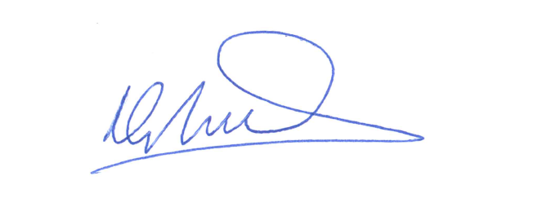
………………………………………………..
Mike Buffham
Chief Commercial Officer
Raspberry Pi Ltd

Date: 16 May, 2024

